Resume
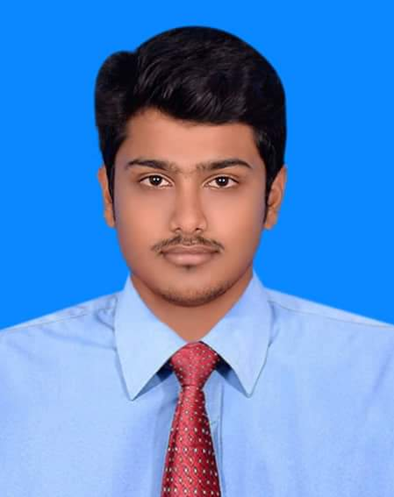
OF
Md. Emran Hossain
Present Address:
Vill: Golora P.O: Kaitta
P.S: Saturia Dist: Manikganj
Cell: 01755785003
01687637449

OBJECTIVE:

To work in a dynamic, intensive environment, where the creativity and interest can be found to develop the skills as well as the career with a strong emphasis on sustained growth and development.

PERSONAL PROFILE:

- Name : Md. Emran Hossain
- Father’s Name : Abdul Mojid Miah
- Mother’s Name : Shefali Begum
- Date of Birth : 27/10/1998
- Sex : Male
- Religion : Islam
- Nationality : Bangladeshi (by birth)
- Marital Status : Unmarried
PERMANENT ADDRES:
Vill: Golora P.O: Kaitta
P.S: Saturia Dist: Manikganj

ACADEMIC QUALIFICATION:

Name of Examination | Year of Passing | Group | GPA/ CGPA | Board / University | Name of Institute
S.S.C | 2014 | Science | 4.81  out of  5 | Dhaka | Manikganj Govt. High School
H.S.C | 2016 | Science | 5.00 out of 5 | Dhaka | Milestone College
B.Sc Engineering | 2020 | Computer Science and Engineering | 3.58 out of 4 | Daffodil International University

LANGUAGE SKILL:
- Bengali : Excellent Reading, writing & Speaking.
- English : Good Reading, Writing & Speaking.

COMPUTER SKILLS:
- Microsoft Office Package:
  - MS Word
  - MS PowerPoint
  - Ms Excel
  - E-mail & Internet Browsing
  - Photoshop
  - Illustrator
  - Video Editing

INTERESTED:

- Badminton
- Reading Book

Special Skill : I have a strong communication skill and leadership skill.

DECLARATION:

- I have by declared that all the details given above are true to the best of my knowledge and believe.

Signature
Date: 01.01.2021

(Md. Emran Hossain)

